Gentle, Effective, Skin Rejuvenation with the AcuLifttmMicroPen

Microneedling effectively treats fine lines, wrinkles, acne scars, improves skin texture and color and dramatically enhances effectiveness of skincare products. Visible results begin on the first day and continue for weeks afterward. As collagen levels continue to build up, your skin becomes more luminous and complexion more even.

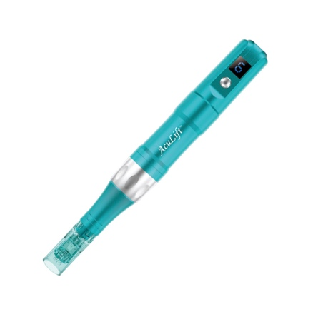Your Acupuncturist is uniquely qualified to perform Microneedling due to their in-depth knowledge of Chinese Medicine. Combining this ancient medicine with modern technology enhances health and beauty from the inside out. Body acupuncture address the internal causes of aging and organ imbalances, which often appear on the face. Relaxing, restorative acupuncture treatments can be combined with microneedling, drastically enhancing the effects.

**The Aculifttm MicroPen is part of the Aculifttm MicroPen SYSTEM**

This system incorporates all organic, vegan doctor formulated serums and pre and post care products for the best possible results.

* Natural Solution
* Little downtime
* Improves appearance

of wrinkles on face and neck

* A collage of a person

  Description automatically generated with medium confidenceSafe for all skin types
* Organic Skin Care Products

Before and After

**Before Treatment**: If desired, topical anesthetic is applied before treatment to provide light numbing.

**Gentle Treatment**: Physician formulated; organic, vegan serum prepared for your skins individual needs will be applied. The AcuLift™ MicroPen is then used to create controlled microchannels, eliciting your body’s healing response. This will remodel and rejuvenate your skin to provide a younger, more firm and radiant appearance.

**Post Treatment**: Following treatment your skin may appear pink or slightly red, similar to a mild sunburn. This typically disappears after 12-24hrs. You will receive a patient aftercare kit to accelerate your recovery and results.

**Results**: Are sometimes apparent after one treatment and will improve over a series of 3-6 monthly treatments. Results will continue to progress for several months after your last treatment. **Results can last up to 5 years!**

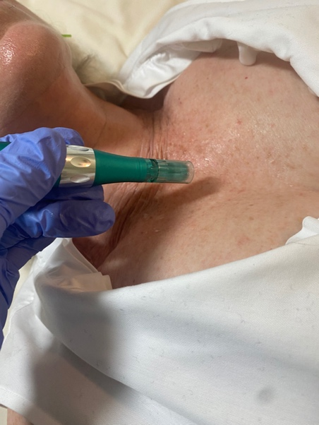

Treat Sun Damage