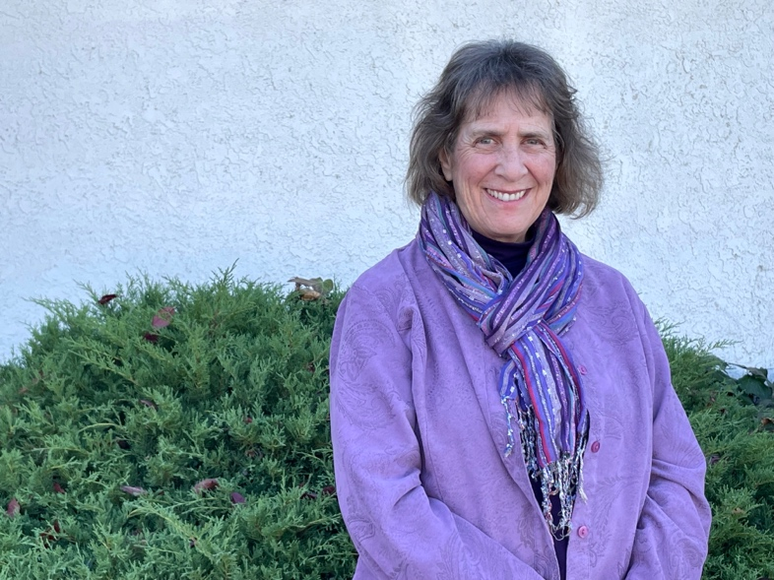

**Wendy Weiss, Licensed Acupuncturist**

2023 Categories Won Gold: Acupuncture