**Herbal Medicine**

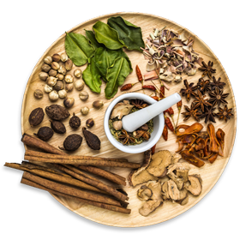

Herbal formulas and acupuncture are complementary therapeutic modalities often used together in the treatment of many conditions. Over the past 5,000 years, Chinese herbology has evolved into an art form of its own. Ancient herbal information was gathered, compiled, formulated, tested and handed down from generation to generation.

Recently, this rich history has been examined through the lens of the scientific method utilized in modern western medicine with promising results. Integrative healthcare professionals in private clinics as well as world renowned facilities like the Cleveland Clinic (clickable link tohttps://health.clevelandclinic.org/what-you-should-know-about-chinese-herbs/) are increasingly including traditional herbal formulas in the treatment of many health issues.

**Prescribing Herbal Formulas**

In traditional Chinese medical theory, various plants, as well as food, are used for their medicinal properties. Herbal formulas are prescribed according to the traditional assessment methods. They are usually either warming, cooling, tonifying, purging, calming or invigorating.

Individual herbs are combined in order to enhance their actions and effects on the body. When combined, a unique, synergistic formula is created. This combination increases the benefits of a particular formula and minimizes any potential side effects. This allows the herbalist to create a formula aimed at addressing individual needs.

The art and skill of creating a formula lies within choosing the precise and most effective herbs that target an individual’s disharmony. It is important to work with a qualified herbalist who can prescribe the correct formula, monitor progress and adjust the dosage and herbs as needed.

**Formulas can be prescribed in a number of ways:**

* Teas
* Liquid extracts
* Pills
* Powders

**Training & Board Certification**

Chinese herbs must be recommended by a skilled practitioner who holds at least a Master’s degree in Acupuncture and Herbal Medicine. Abigail Thomas holds a Doctorate of Acupuncture and Chinese Medicine (DACM) and is a board certified by the NCCAOM (hyperlink to <https://www.nccaom.org/find-a-practitioner-directory/>). She has completed multiple post-graduate mentorship programs of study, focusing on herbal formulation for women’s health conditions.